AAUW NC Annual Meeting - March 25, 2023 via Zoom
REGISTER for AAUW NC ANNUAL MEETING - SAT. MARCH 25, 9:30 a.m - 12:30 p.m.
- Bs sure to select your Annual Meeting Breakout Session from the 3 options!

Annual Meeting Agenda and Key Topics
- Annual Meeting Agenda
- AAUW NC Young People’s Literature Award and Author, Micki Bare, for book, “Society of the Sentinelia”
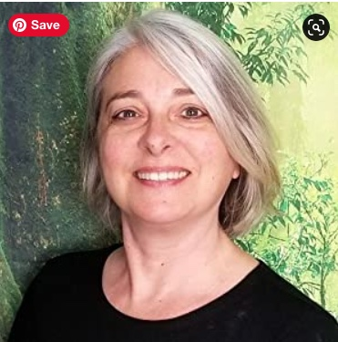
- Breakout Sessions
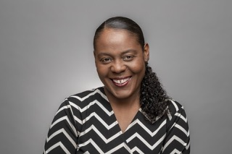
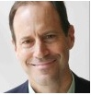
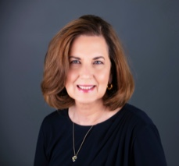
There will be three (3) breakout sessions for the Annual Meeting. Each session will have a Facilitator to help guide the discussion. The Facilitators are identified below along with their pictures and some biographical information. We hope you enjoy these sessions where you can be more actively engaged.
Membership, Inclusion to Belonging: Facilitator - Tiffany Jacobs, AAUW NC Diversity Equity and Inclusion (DEI) Chair
Tiffany supports many roles within AAUW and with other organizations including the following:
- Member of the AAUW National Inclusion Equity (I&E) Committee
- Selected in 2022 by the Triad Business Journal as an Outstanding Woman in Business
- Senior Advisor at the Community Foundation of Greater Greensboro for Degrees Matter. Degrees Matter is aimed to reconnect adults to post-secondary educational opportunities in an effort to increase adult degree completion.
- Active board member of the AAUW Greensboro Branch supporting: the Girls Exploring Tools and Tech (GETT) and Women in Nontraditional Careers (WINc) initiatives, DEI and membership committees.
- Board member/Diversity Officer for the FORGE Greensboro, that serves as a training ground for career exploration, skilled trades, and entrepreneurship.
- Currently employed by the Economic Development Division of the North Carolina Community College System, as the Piedmont Triad Apprenticeship Regional Coordinator with ApprenticeshipNC.
2023 Political Landscape: Facilitator - Rob Schofield, NC Justice Center, Policy Watch Director
Rob Schofield, NC Policy Watch Director, has three decades of experience as a lawyer, lobbyist, writer and commentator. At Policy Watch, Rob writes and edits daily online commentaries and handles numerous public speaking and electronic media appearances. He also delivers a radio commentary that’s broadcast weekdays on WRAL-FM and WCHL and hosts News and Views, a weekly radio news magazine that airs on multiple stations across North Carolina.
Branch Leadership Succession: Facilitator - Jeanie Latz, AAUW Board Member
Jeanie Sell Latz has led across public, private, academic, and non-profit sectors. She was a C-suite executive at a Fortune 1000 company; taught strategy and law at the Bloch School of Management at the University of Missouri—Kansas City; and chaired a number of not-for-profit boards. She currently consults in the areas of corporate governance and strategy. As a Governance Fellow, National Association of Corporate Directors, Jeanie lends her expertise to a number of organizations. She received a BS in Business Education from Missouri State University and a Juris Doctorate from the University of Missouri.
- Keynote Speaker, Keynote Speaker Malinda Gaul, AAUW Vice-Chair
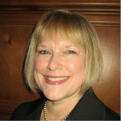
Malinda Gaul is the senior partner at Gaul and Dumont, an employment law firm primarily representing employees. Malinda is a Fellow with the College of Labor and Employment Lawyers and a member of the American Board of Trial Advocates.
Malinda joined the San Antonio, Texas Branch of AAUW in 1989, and has served in many capacities from Legal Advocacy Fund Liaison to President. She has also been active on the AAUW Texas Board, including being President, and currently is the AAUW National Vice Chair.
In addition to her work with AAUW, Malinda is on the board of San Antonio Youth Literacy, Equal Justice Center, and Merced Housing Texas.

